1
Activity Log
3rd Monaghan Scout group
Virtual Hike Challenge

Name:______________________ Scouter Section:________________________________
 |  |  |  |  |  | 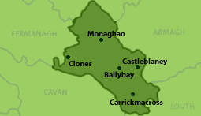
 | Day |  | Day | Time | Type of activity | Area of Activity | Distance
 | 1
 | 2
 | 3
 | 4
 | 5
 | 6
 | 7
 | 8
 | 9
 | 10
 | 11
 | 12

